**UNIT-IV**

**Conventional & non-conventional energy source:**

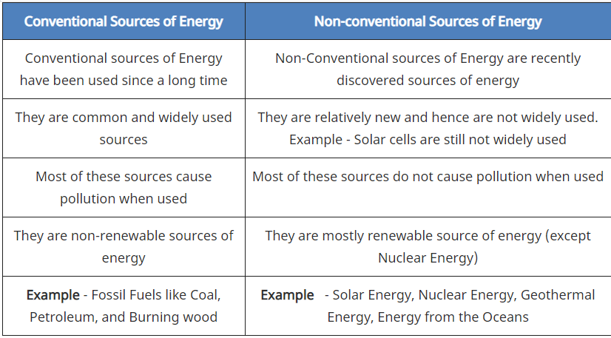

**What is the biological energy?**

 "**biological energy**" as a convention to refer to a specific social and technological endeavor: to use the **metabolic capacities of** **organism**s to convert some combination of light, biomass, organic compounds, gases and water into useful chemical-bond **energy**; i.e. storable, transportable, **energy** yielding.

**Examples** include hydrogen, methane, alcohols, ammonia and bioplastics. The purpose of designing and developing **biological energy** systems is to reduce the emissions of greenhouse gases and provide environmentally friendly alternatives to some industrial processes. **Biological energy** is sustainable technology.

**What is fossil fuel?**

A **fossil fuel** is a [**fuel**](https://en.wikipedia.org/wiki/Fuel)**formed by**[**natural**](https://en.wikipedia.org/wiki/Natural)**processe**s, such as [anaerobic decomposition](https://en.wikipedia.org/wiki/Anaerobic_decomposition) of buried dead [organisms](https://en.wikipedia.org/wiki/Organism), containing energy originating in ancient [photosynthesis](https://en.wikipedia.org/wiki/Photosynthesis).Such organisms and their resulting fossil fuels typically have an age of millions of years, and sometimes more **than 650 million** years.Fossil fuels contain high percentages of [carbon](https://en.wikipedia.org/wiki/Carbon) and include [petroleum](https://en.wikipedia.org/wiki/Petroleum), [**coal**](https://en.wikipedia.org/wiki/Coal)**, and**[**natural gas**](https://en.wikipedia.org/wiki/Natural_gas)**. Commonly used derivatives of fossil fuels include**[**kerosene**](https://en.wikipedia.org/wiki/Kerosene)**and**[**propane**](https://en.wikipedia.org/wiki/Propane)**.** Fossil fuels range from [volatile](https://en.wikipedia.org/wiki/Volatility_(chemistry)) materials with low [carbon](https://en.wikipedia.org/wiki/Carbon)-to-[hydrogen](https://en.wikipedia.org/wiki/Hydrogen) ratios (like [methane](https://en.wikipedia.org/wiki/Methane)), to liquids (like petroleum), to nonvolatile materials composed of almost pure carbon, like [anthracite](https://en.wikipedia.org/wiki/Anthracite) coal.

**What is Wind Energy? and their major components:-**

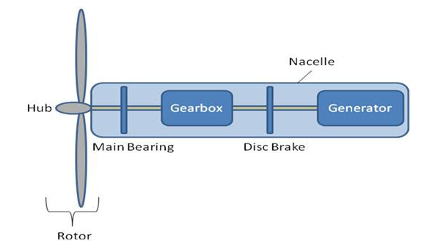

Wind energy is a form of solar energy. Wind energy (or wind power) describes the process by which wind is used to generate electricity. Wind turbines convert the **kinetic energy in the wind into mechanical power**. A generator can convert mechanical power into electricity.

**Wind Energy Parts And Working:-**

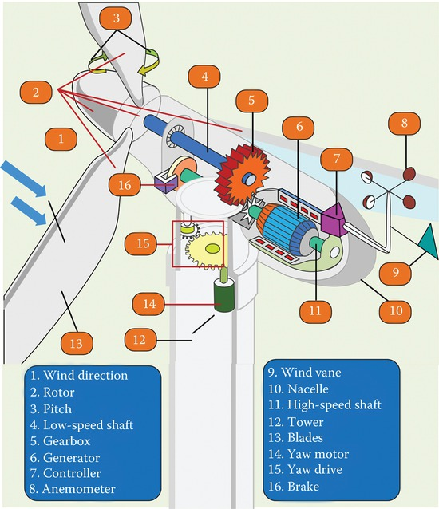

**Anemometer:**

Measures the wind speed and transmits wind speed data to the controller.

**Blades:**

Lifts and rotates **when wind** is blown over them, causing the rotor to spin. Most turbines have either two or three blades.

**Brake:**

Stops the rotor **mechan**ically, electrically, or hydraulically, in emergencies.

**Controller:**

Starts up the machine at wind speeds of about 8 to 16 miles per hour (mph) and shuts off the machine at **about 55 mph**. Turbines do not operate at wind speeds above about 55 mph because they may be damaged by the high winds.

**Gear box:**

Connects the low-speed shaft to the high-speed shaft and increases the rotational speeds from about 30-60 rotations per minute (rpm), to about 1,000-1,800 rpm; this is the rotational speed required by most generators to produce electricity. The gear box is a costly (and heavy) part of the wind turbine and engineers are exploring "direct-drive" generators that operate at lower rotational speeds and don't need gear boxes.

**Generator:**

Produces 60/50-cycle AC electricity; it is usually an off-the-shelf induction generator.

**High-speed shaft:**

Drives the g**ener**ator.

**Low-speed shaft:**

Turns the low-speed shaft at about 30-60 rpm.

**Nacelle:**

Sits atop the tower and contains the gear box, low- and high-speed shafts, generator, controller, and brake. Some nacelles are large enough for a helicopter to land on.

**Pitch:**

Turns (or pitches) blades out of the wind to control the rotor speed, and to keep the rotor from turning in winds that are too high or too low to produce electricity.

**Rotor:**

Blades and hub together form the rotor.

**Tower:**

Made from tubular steel (shown here), concrete, or steel lattice. Supports the structure of the turbine. Because wind speed increases with height, taller towers enable turbines to capture more energy and generate more electricity.

**Wind direction:**

Determines the design of the turbine. Upwind turbines—like the one shown here—face into the wind while downwind turbines face away.

**Wind vane:**

A measure wind direction and communicates with the yaw drive to orient the turbine properly with respect to the wind.

**Yaw drive:**

Orients upwind turbines to keep them facing the wind when the direction changes. Downwind turbines don't require a yaw drive because the wind manually blows the rotor away from it.

**Yaw motor:**

Powers the yaw drive.

**Fluid dynamics in wind energy conversion**

As the fluid flows over the blade of the turbine, the blades have such design that the velocity of fluid flowing above and below the turbine blades are different and hence creating a pressure difference between above and below the blade and so exerting a net force and giving a rotation to the shaft of the turbine.

**Betz law to receive maximum energy**

The Betz limit is the theoretical maximum efficiency for a wind turbine, conjectured by German physicist Albert Betz in 1919. Betz concluded that this value is 59.3%, meaning that at most only 59.3% of the kinetic energy from wind can be used to spin the turbine and generate electricity.

**Effect of number of rotor blades on performance efficiency**

Too few a number of blades results in poor efficiency and thus inadequate performance. Too large a number of blades increases weight and production cost. The correct number of blades is important to fit the generator performance curve to optimize overall turbine performance and efficiency.

**Wind-turbine aerodynamics**

The primary application of wind turbines is to generate energy using the wind. Hence, the aerodynamics is a very important aspect of wind turbines. Like most machines, there are many different types of wind turbines, all of them based on different energy extraction concepts. Though the details of the aerodynamics depend very much on the topology, some fundamental concepts apply to all turbines. Every topology has a maximum power for a given flow, and some topologies are better than others. The method used to extract power has a strong influence on this. In general, all turbines may be grouped as being either lift-based, or drag-based; the former being more efficient. The difference between these groups is the aerodynamic force that is used to extract the energy.

The most common topology is the horizontal-axis wind turbine. It is a lift-based wind turbine with very good performance. Accordingly, it is a popular choice for commercial applications and much research has been applied to this turbine. Despite being a popular lift-based alternative in the latter part of the 20th century, the Darrieus wind turbine is rarely used today. The Savonius wind turbine is the most common drag type turbine. Despite its low efficiency, it remains in use because of its robustness and simplicity to build and maintain.

**Wind energy benefits**

* Renewable energy
* Inexhaustible
* Not pollutant
* Reduces the use of fossil fuels
* Reduces energy imports
* Creates wealth and local employment
* Contributes to sustainable development

# Types of wind turbines

There are two different **types of wind turbines**. These turbines are often used for microgeneration, meaning that they can be installed for a home to [generate electricity](https://energyeducation.ca/encyclopedia/Generate_electricity). Both of these types of wind turbines have advantages and disadvantages.

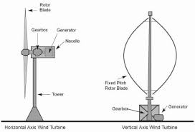

### Horizontal axis wind turbines

Horizontal axis wind turbines are the most commonly used turbines due to their strength and [efficiency](https://energyeducation.ca/encyclopedia/Efficiency). The base of the towers have to be extremely strong, allowing the rotor shaft to be installed at the top of the tower which allows the turbine to be exposed to stronger winds. With the blades of the [turbine](https://energyeducation.ca/encyclopedia/Turbine) being perpendicular to the [wind](https://energyeducation.ca/encyclopedia/Wind), the rotation of the blades can generate more [power](https://energyeducation.ca/encyclopedia/Power) compared to the vertical axis wind turbine. However, the construction of this type of turbine requires a heavy support for the tower to support the weight of the blades, gearbox and [generator](https://energyeducation.ca/encyclopedia/Generator) as well as utilizing a sizable crane to lift the components to the top of the tower.

In a situation where the wind is blowing downwards, the turbine structure may suffer from metal fatigue which could lead to a structural failure. This is resolved by designing the turbines with an upwind design. Additional [yaw](javascript:%20void(0)) control is needed for the horizontal axis wind turbines in order to track the direction of the wind, to prevent damaging the turbine.

### Vertical axis wind turbines

Vertical axis wind turbines are less affected by frequent wind direction changes as compared to the horizontal axis wind turbines due to the blades being rotated on the rotor shaft perpendicular to the ground. With the blades and shaft installed in this way, the [turbine](https://energyeducation.ca/encyclopedia/Turbine) does not need to rotate to track [wind](https://energyeducation.ca/encyclopedia/Wind) direction. The shaft is mounted near ground level due to the difficulties of mounting the shaft and its components on the tower. An advantage of being mounted at ground level is that maintenance of the turbine is easier and can be installed at locations such as rooftops. Disadvantages to this turbine installation is that the efficiency is lower due to [air drag](https://energyeducation.ca/encyclopedia/Air_drag) and the lower wind speeds compared to the higher wind speeds encountered at higher elevations.

**Wind Farm:-**

* A wind farm or wind park, also called a wind power station or wind power plant, is a group of wind turbines in the same location used to produce electricity. Wind farms vary in size from a small number of turbines to several hundred wind turbines covering an extensive area. Wind farms can be either onshore or offshore.

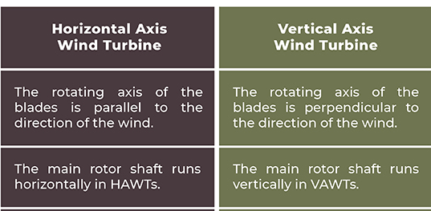

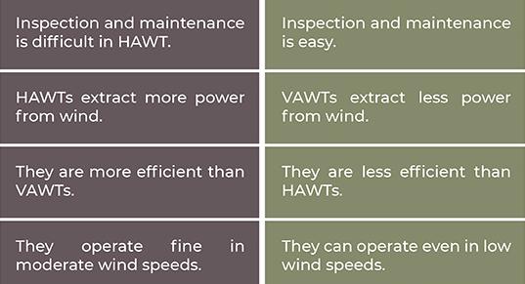

**Types Of Generators Used In Wind Turbine System**

Several different types of generators which are used in wind turbines are as follows. **Asynchronous (induction) generator** and **synchronous generator.** Squirrel cage **induction generator (SCIG) and wound rotor induction generator (WRIG) are comes under asynchronous generators**. **Wound rotor generator (WRSG) and permanent magnet generator (PMSG) are** comes under synchronous generator. Detailed explanation is given.

1. **Asynchronous Generator:-** Squirrel Cage Induction Generator The fixed speed concept is used in this type of wind turbine. In this configuration the Squirrel Cage Induction Motor is directly connected to the wind through a transformer is shown in the figure. A **capacitor bank is here for reactive power compensation and soft starter is used for smoot**h grid connection. It does not support any speed control is the main disadvantage

` 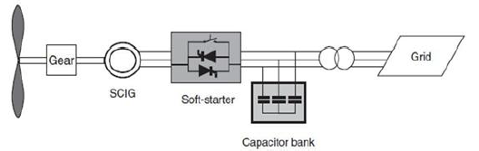

1. **Wound rotor induction generator ( WRIG ):-** The variable speed concept is used in this type .In this type of turbine Wound Rotor Induction Generator is directly connected to the grid as shown in the figure. **The variable rotor resistance is for controlling slip and** power output of the generator. The soft starter used here for reduce inrush current and reactive power compensator is used to eliminate the reactive power demand .The speed range is limited , **poor control of active and reactive power, the slip power is dissipated in the variable resistance** as losses are the disadvantages of this configuration.

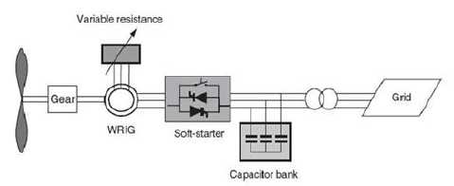

1. **Wound Rotor Generator:-** Turbine with wound rotor connected to the grid is shown in fig.4.This configuration neither require soft starter nor a reactive power comparator is its main advantage. The partial scale frequency converter used in the system will perform reactive power compensation as well as smooth grid connection. The wide range of dynamic speed control is depends on the size of frequency converter .the main disadvantage is that in the case of grid fault it require additional protection and use slip rings, this makes electrical connection to the rotor.

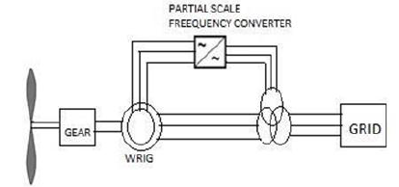

1. **Permanent Magnet Generator:-** The generator is **connected to the grid via full scale frequency converter. The frequency converter helps to control both the active and reactive power delivered** by the generator to grid.

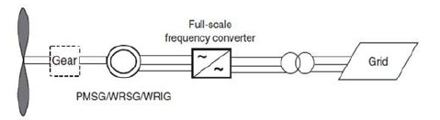

1. **Doubly Fed Induction Generator:-** Doubly fed induction generator based wind turbine system have **more advantages than** others. DFIG wind **turbine deliver power through the stator and rotor of the generator the reactive power can provide in two sides. Hence use the term doubly. Reactive power can be supported either through grid side converter or through rotor side converter.** The stator part of the turbine is directly connected to the grid and the rotor is interfaced through a crowbar and a power converter

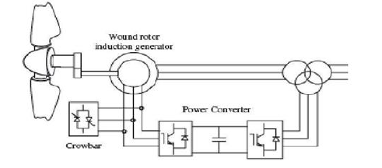

**What is wind Farm?**

A wind farm **or wind park**, also called a wind power station or wind power plant,is a group **of wind turbines in the same location used to produce electricity. Wind farms vary in size from** a small number of turbines to several hundred wind turbines covering an extensive area. Wind farms can be **either onshore or offshore.**

**Wind farms tend to have much less impact** on the environment than many other power stations. Onshore wind farms are also criticized for their visual impact and impact on the landscape, as typically they need to take up more land than other power stations and need to be built in wild and rural areas, which can lead to "industrialization of the countryside", habitat loss, and a drop in tourism.

**GEOTHERMAL POWER PLANT**

Geothermal energy is the heat that comes from the **sub-surface of the** earth. It is contained in the **rocks and fluids beneath** the earth’s crust and can be found as far down to the earth’s **hot molten rock**, magma. To produce power from geothermal energy, wells are dug a mile deep into underground reservoirs to access the steam and hot water there, which can then be used to drive turbines connected to electricity generators. There are three types of geothermal power plants; dry steam, flash and binary.

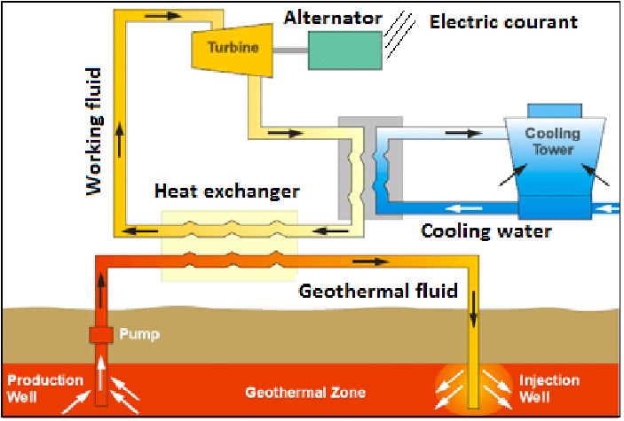

Dry steam is the oldest form of geothermal technology and takes steam out of the ground and uses it to directly drive a turbine. Flash plants use high-pressure hot water into cool, low-pressure water whilst binary plants pass hot water through a secondary liquid with a lower boiling point, which turns to vapour to drive the turbine.

**Pros and Cons of geothermal energy:-** geothermal energy **as a “carbon-free, renewable, sustainable form of energy that provides a continuous, uninterrupted supply of heat that can be used to heat homes and office buildings** and to generate electricity.” Geothermal energy only produces one-sixth of the CO2 produced by a natural gas plant and is not an intermittent source of energy like wind or solar.

However, there are some drawbacks to the energy source. Despite low CO2 production geothermal has been associated with other emissions like sulphur dioxide and hydrogen sulphide. Similar to fracking, geothermal power plants have been the cause of mini tremors in the area they operate in and also has a high initial cost to build. It is also described as “the most location-specific energy source known to man” due to its activity being along the tectonic plates of the earth’s crust.

## The Future of Geothermal Energy

With current technology, geothermal power plants can only be built where steam or hot water geothermal sources exist. Scientists are working on ways to create cost efficient power plants that can use the geothermal sources created from the earth's magma.

**OCEAN THERMAL ENERGY CONVERSION (OTEC)**

Ocean Thermal Energy Conversion (OTEC) is a **process that can produce electricity by using the temperature difference between deep cold ocean water and warm tropical surface waters.** OTEC plants pump large quantities of deep cold seawater and surface seawater to run a power cycle and produce electricity. OTEC is firm power (24/7), a clean energy source, environmentally sustainable and capable of providing massive levels of energy.

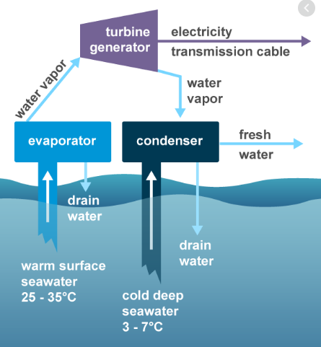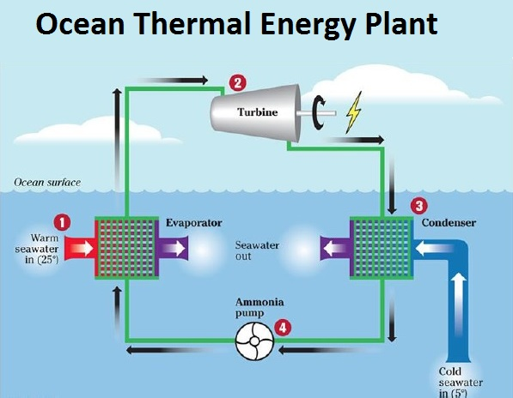

Recently, higher electricity costs, **increased concerns for global warming, and a political commitment to energy security have** made initial OTEC commercialization economically attractive in tropical island communities where a high percentage of electricity production is oil based.

### HOW IT WORKS

Eighty percent of the sun’s solar energy is absorbed into the surface of the world’s oceans, and it is replenished daily regardless of weather patterns. In a closed cycle OTEC system, water flows through a large pipe and heat exchanger, which heats a liquid with a low boiling point, such as ammonia. As the boiling ammonia creates steam, it turns a turbine generator to produce electricity. A second pipe extracts cool deep water from the ocean, which condenses the steam back to liquid form. As the ammonia is recycled, the process repeats, creating unlimited clean energy 24 hours a day, 365 days a year. This process is known as the [Rankine cycle](https://en.wikipedia.org/wiki/Rankine_cycle), commonly found in typical oil, coal, or nuclear power generation plants. The difference with OTEC is that it uses the solar energy from the ocean – **no fossil fuels are used in OTEC’s power generation.**

**OCEAN THERMAL ENERGY CONVERSION:-** Ocean Thermal Energy Conversion (OTEC) is a game-changing technology that leverages the temperature difference in the ocean between cold deep water and warm surface water in the tropics and subtropics to generate unlimited energy without the use of fossil fuels. It boasts a competitive advantage over alternative sources of electricity production regarding accessibility, predictability, affordability, and emissions.

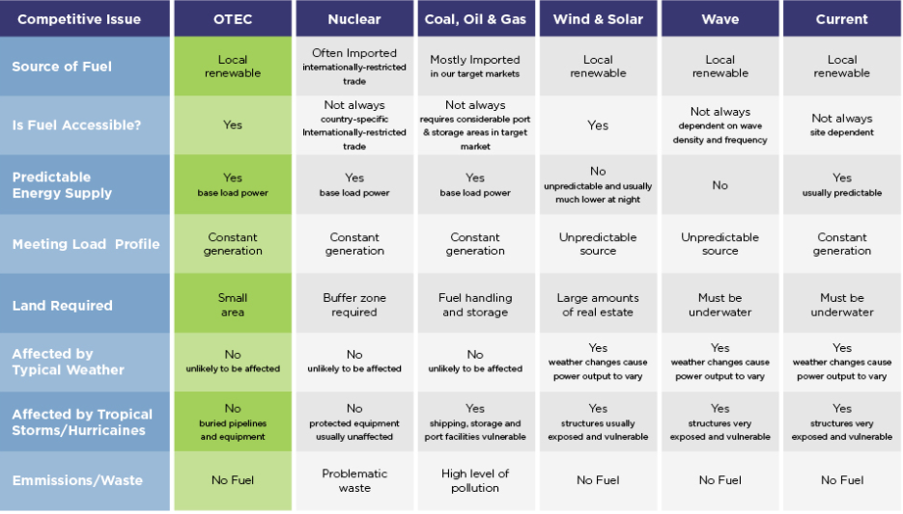

**TIDAL POWER PLANT**

**Working principle of Tidal power plants:-** Tide or wave is periodic rise and fall of water level of the sea. Tides occur due to the attraction of sea water by the moon. Tides contain large amount of potential energy which is used for power generation. When the water is above the mean sea level, it is called flood tide. When the water level is below the mean level it is called ebb tide.

**Working**:- The arrangement of this system is shown in figure. The ocean tides rise and fall and water can be stored during the rise period and it can be discharged during fall. A dam is constructed separating the tidal basin from the sea and a difference in water level is obtained between the basin and sea.

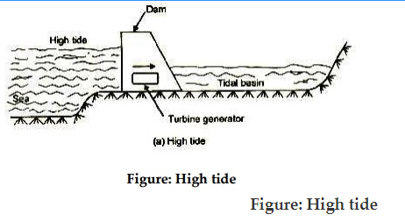

During high tide period, water flows from the sea into the tidal basin through the water turbine. The height of tide is above that of tidal basin. Hence the turbine unit operates and generates power, as it is directly coupled to a generator.

During low tide period, water flows from tidal basin to sea, as the water level in the basin is more than that of the tide in the sea. During this period also, the flowing water rotates the turbine and generator power.

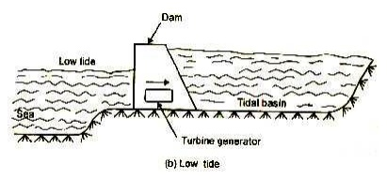

**Figure : Low tide**

**Advantages of tidal power plants.**

1.     It is free from pollution as it does not use any fuel.

2.     It is superior to hydro-power plant as it is totally independent of rain.

3.     It improves the possibility of fish farming in the tidal basins and it can provide recreation to visitors and holiday makers.

**Disadvantages**

1.     Tidal power plants can be developed only if natural sites are available on the bay.

2.     As the sites are available on the bays which are always far away from load centres, the power generated has to be transmitted to long distances. This increases the transmission cost and transmission losses.

**Wave energy**

Wave energy (or wave power) is the transport and capture of energy by ocean surface waves. The energy captured is then used for all different kinds of useful work, including electricity generation, water desalination, and pumping of water.

Wave energy is a form of renewable energy that can be harnessed from the motion of the waves. There are several methods of harnessing wave energy that involve placing electricity generators on the surface of the ocean.

## How Does Wave Energy Work?

Depending on the lunar cycles, tides, winds, and weather, waves can vary in size and strength. As waves roll through the ocean, they create kinetic energy, or movement. This movement can be used to power turbines, which, in turn, create energy that can be converted into electricity and power. There are also several ways of harnessing wave energy that utilize the up and down motion of the waves to power pistons/turn generators.

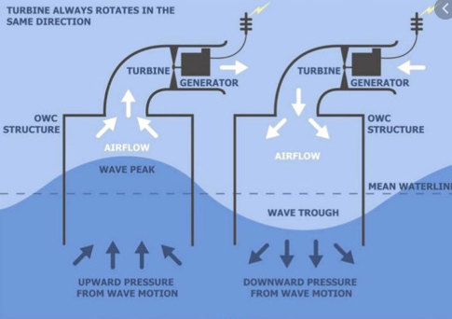

Wave energy or wave power is essentially power drawn from waves. When wind blows across the sea surface, it transfers the energy to the waves. They are powerful source of energy. The energy output is measured by wave speed, wave height, wavelength and water density.

**HYDRO POWER PLANT**

Hydropower plants capture the energy of falling water to generate electricity. A turbine converts the kinetic energy of falling water into mechanical energy. Then a generator converts the mechanical energy from the turbine into electrical energy.

## Layout and working of hydroelectric power plant

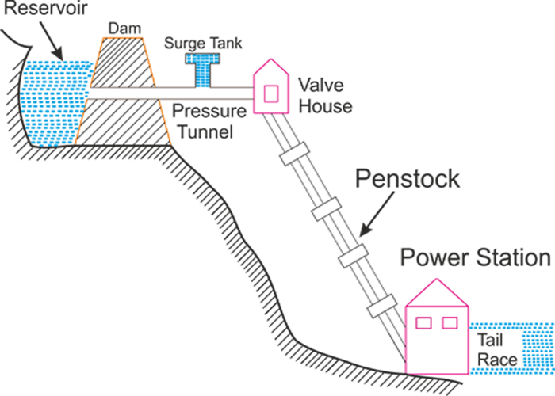

**Dam and Reservoir:** The dam is constructed on a large river in hilly areas to ensure sufficient water storage at height. The dam forms a large reservoir behind it. The height of water level (called as water head) in the reservoir determines how much of potential energy is stored in it.

**Control Gate:** Water from the reservoir is allowed to flow through the penstock to the turbine. The amount of water which is to be released in the penstock can be controlled by a control gate. When the control gate is fully opened, maximum amount of water is released through the penstock.

**Penstock:** A penstock is a huge steel pipe which carries water from the reservoir to the turbine. Potential energy of the water is converted into kinetic energy as it flows down through the penstock due to gravity.

**Water Turbine:** Water from the penstock is taken into the water turbine. The turbine is mechanically coupled to an electric generator. Kinetic energy of the water drives the turbine and consequently the generator gets driven. There are two main types of water turbine; (i) Impulse turbine and (ii) Reaction turbine. Impulse turbines are used for large heads and reaction turbines are used for low and medium heads.

**Generator:** A generator is mounted in the power house and it is mechanically coupled to the turbine shaft. When the turbine blades are rotated, it drives the generator and electricity is generated which is then stepped up with the help of a transformer for the transmission purpose.

**Surge Tank:** Surge tanks are usually provided in high or medium head power plants when considerably long penstock is required. A surge tank is a small reservoir or tank which is open at the top. It is fitted between the reservoir and the power house. The water level in the surge tank rises or falls to reduce the pressure swings in the penstock. When there is sudden reduction in load on the turbine, the governor closes the gates of the turbine to reduce the water flow. This causes pressure to increase abnormally in the penstock. This is prevented by using a surge tank, in which the water level rises to reduce the pressure. On the other hand, the surge tank provides excess water needed when the gates are suddenly opened to meet the increased load demand.

### Advantages of a hydroelectric power plant

* No fuel is required as potential energy is stored water is used for electricity generation
* Neat and clean source of energy
* Very small running charges - as water is available free of cost
* Comparatively less maintenance is required and has longer life
* Serves other purposes too, such as irrigation

#### Disadvantages

* Very high capital cost due to construction of dam
* High cost of transmission – as hydro plants are located in hilly areas which are quite away from the consumers